# Website development.

I decided to do the website development from scratch, as this should give me more control and power over the website layout and design. This unfortunately will sacrifice out of the box mobile support, as well as a built in grid framework.

After deciding which design, I was going to construct, I then began building a basic scaffold for my website. The scaffold is built off the HTML5 specification, and attempts to create a basic template which I can build on top of. I have decided not to employ the use of any third party stylesheets, or libraries. I have done this because they are heavyweight and create a less reactive website. It is generally bad practice to use these libraries in production, as they often include many features and styles which are not used by the website. By building the website from scratch, I have complete control over the design, and can implement only the necessary features of the website.

A downside to building the website from scratch is that in order to make the website mobile friendly, I will have to implement these features myself. This is not required by the brief, and therefore I will not be including this in my website, unless I finish the project early.

The basic scaffold can be seen below. The headings, leading, and text colour have been adjusted to create a more pleasant experience. I made the text colour a dark grey, since pure black text on white can often be too much contrast. It looks much softer when changed to a dark grey.

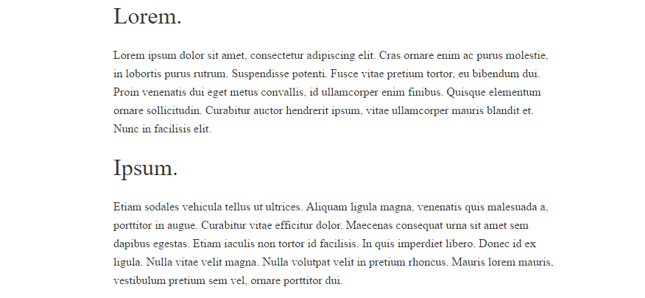

The next task is to build the header of the website, as seen in my sketch. This several key elements, including the logo, navigation and kicker, which would be placed on top of a cover image.

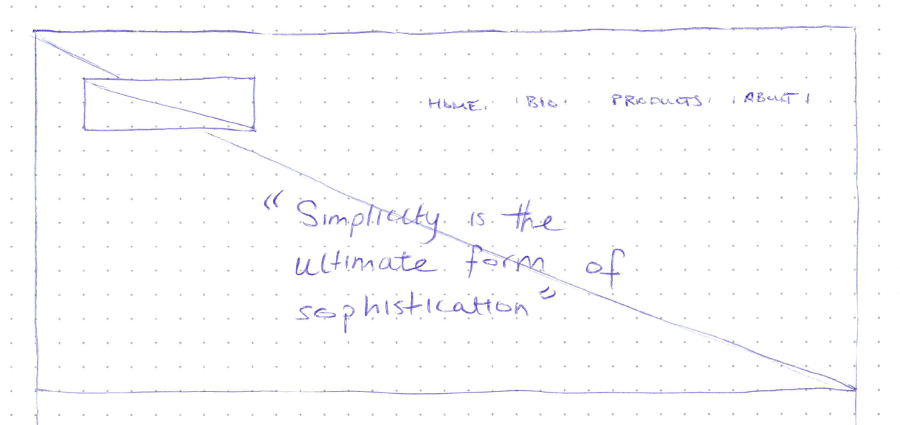

I built out the basic layout in HTML, but without styles it did not look like much. I then began to create the corresponding styles to make the header look the following way. I was able to get it to the following point, whereby all of the elements are roughly in position.

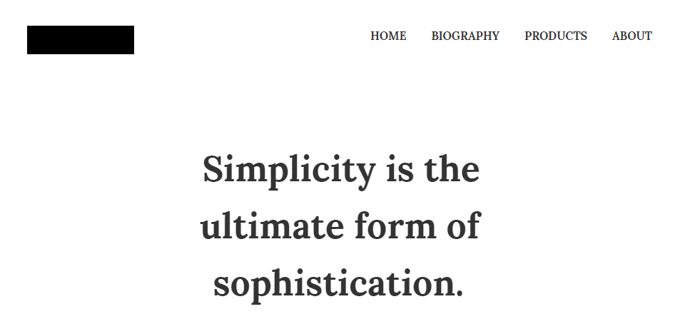

Next I need to start placing in assets such as the logo, as well as the cover image. This was relatively easy to do. The cover image I chose to work from is from Unsplash, and the license can be found in the assets document.

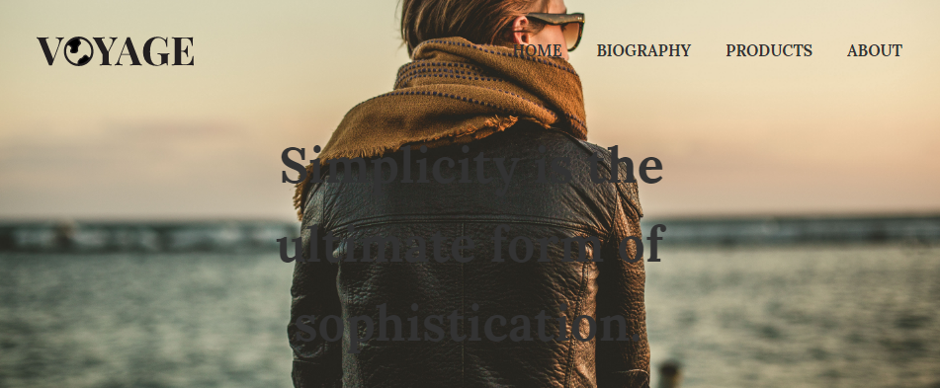

The logo looks good, however it is quite clear that the image and typography of the kicker are conflicting. Not only that, but on wide screens the cover image breaks down.



These were both unpredicted problems, which I did not forecast in my sketch. I did not consider that cover image would conflict with the typography and it would break down on wide screens. The wide screen issue was quite easy to fix. I adjusted some CSS properties, so that the image was aligned to the bottom of the image. I also adjusted the image in Photoshop.

The original image can be seen below. In order to fix the image scaling effect, we have to make the image wider so that it fits better on widescreen displays.



In Photoshop, I first cropped the image so that it immediately become wider. After some testing I found that this was not wide enough. In order to get the extra width, I increased the canvas width, and then used Photoshop’s content aware fill to automatically generate more sky.



It is clear that the sky on the left and right do not look quite correct, however it has done a good enough job so that it is not noticeable once on the website. I then began to play around with the kicker typography, but I couldn’t find a solution. I tried putting transparent backgrounds behind the text, but I didn’t like any of my solutions. I asked Luke for his opinion, and he told me that he believed the cover image and kicker text were both fighting for the centre of the page, which was why it was difficult to fix. After hearing this, I decided that I would just remove the kicker text for the time being, and try and find a better position for it.

Below is a screenshot of what the website looks in widescreen after the cover image had been fixed.



In this lesson, I decided to work on the main content that appears below the header of the website. I tried moving the kicker down below, and I believe it looks much better down here, rather than on top of the cover image. I also worked on copying in some of the content which I have written to get a feel for how it looks.



Most of it looks good for the moment, so I will move onto creating the footer for the website. I may need to include more content on the home page, such as a grid of images, because at the moment it is looking quite bare.

I quickly created a footer for the website. It doesn’t have to be anything fancy, it just needs to be discrete, but easy to find if someone is looking for it.

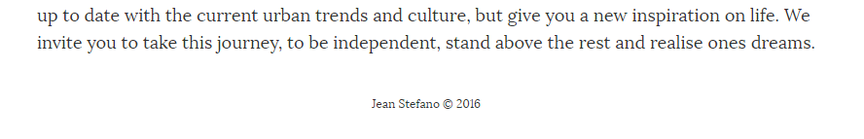

I also decided that the home page was looking pretty plain, so I decided to create a quick image grid, with a variety of images I sourced from Unsplash. All licensing can be found in the assets document. It was more difficult than I anticipated to get it to scale with the screen size, but after Googling the issue I was able to find a few solutions which helped. In the end I used the new CSS property flexbox to help align the elements.

* <https://css-tricks.com/snippets/css/a-guide-to-flexbox/>
* <https://developer.mozilla.org/en-US/docs/Web/CSS/CSS_Flexible_Box_Layout>

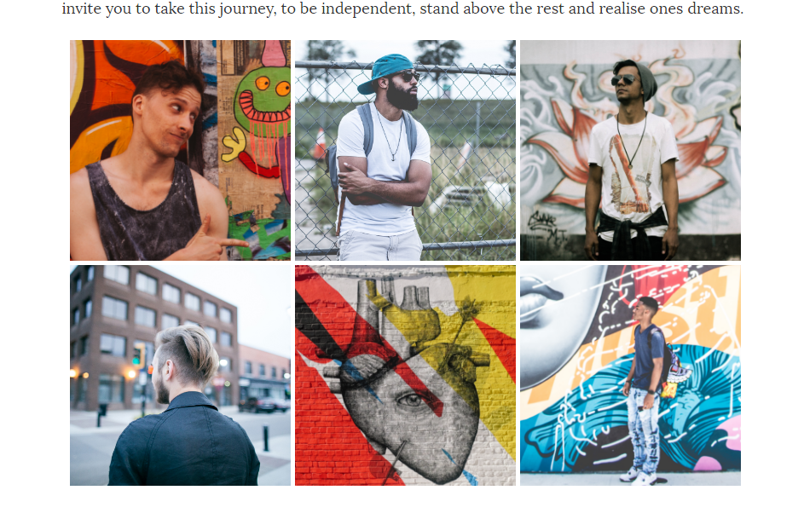

The result looks good, and it gives the page more substance and character. The extra colour also makes the bottom of the page more vibrant, and more pleasant to look at.

In today’s lesson I began by starting to build the other pages of the website. Most of the hard work has been completed in the template, as the styles and HTML template are already in place. I began by inserting the content on the biography page. All the styles for the headings and paragraphs are in place. The page looks fairly bland, so I may go through the content and use italics and bold styles to emphasise certain parts of the text.

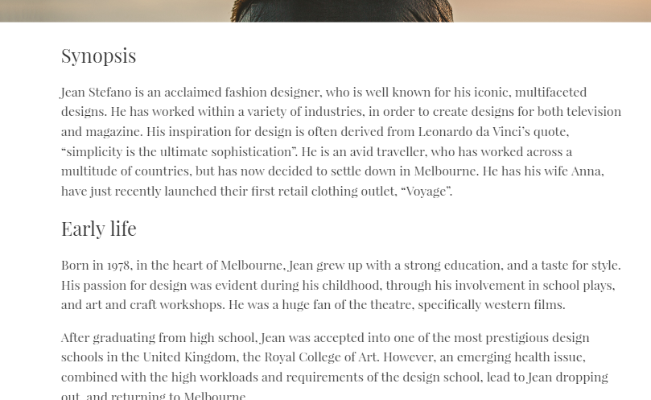

Next I began working on the about page, which contains the address and other details. This page took quite a while to make, despite its apparent simplicity. The décor text was easy to implement, but I had some problems with the three column layout.

Since I already had the grid system, which I used to make the image grid on the home page, I decided that I would try to reuse this grid system to create this three column layout. Since the grid system was tailored more for images I was having trouble trying to use it for text. Instead of trying to make a creative solution, I decided just to make another style for a nearly identical grid system, that does work for this text. While it isn’t the most elegant CSS solution, it works, and it looks good.

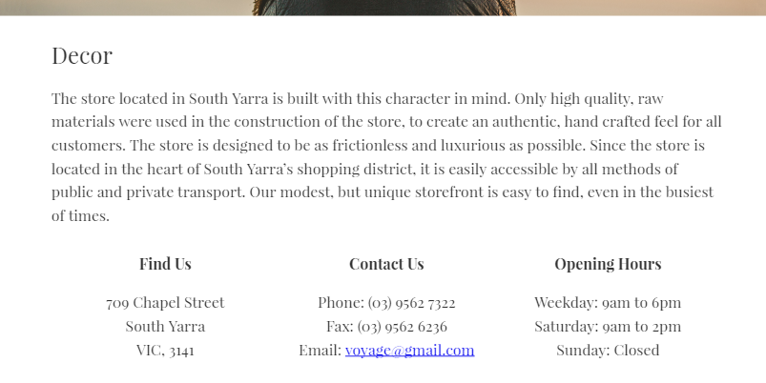

I also used the website, <http://www.map-embed.com/>, to create a map to embed at the bottom of the page. After generating the map, I noticed that it didn’t span the full page width. However, by creating some custom CSS styles I was able to make it so that it responsively scales to the correct size.

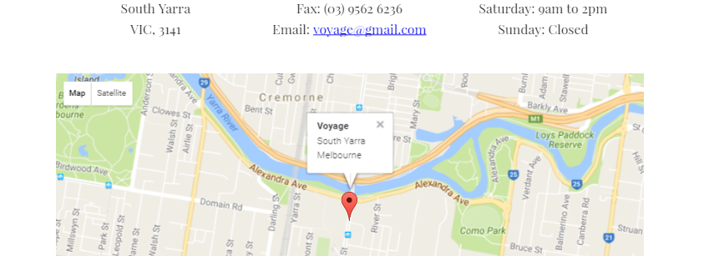

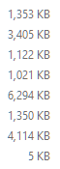I noticed that even though the website was hosted locally, it was beginning to have a slower load time, and image effects were beginning to display latency. After looking into the images folder, it was clear that the images were enormous in size. If I am experiencing delay while working on the website locally, then once it is hosted this would produce considerable delay.

In order to resolve these issues, I decided I would need to optimise the images in the assets folder. I decided to resize the thumbnails down from their dimensions of over 2000 pixels wide, to a more respectable 300 pixels wide.

In the process I discovered that the cover image was nearly 10000 pixels in width. I decided that a width of 2000 pixels should be more than enough for almost any modern display.

After resizing all of the images, the file sizes of the images now rests at around 100 KB per image, which is a tiny fraction of the original size. There is probably still much more room for improvement, however for the moment these sizes are satisfactory. When refreshing the webpage, there is no noticeable difference in the quality of the images.

Since I am running on schedule, I decided I had some extra time to create some dividers. I decided that the public domain travel icons would look really good as a divider. This divider should help break up the content, and make the content easy to digest.

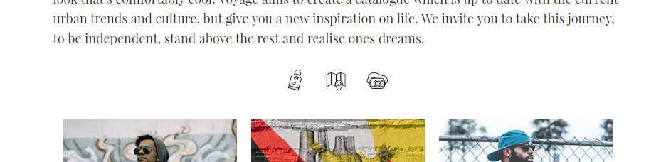

I decided to place the mock-up of the storefront on the about page. This was extremely simple, as my current image grid framework allowed me to quickly place this image onto the page and centre it.

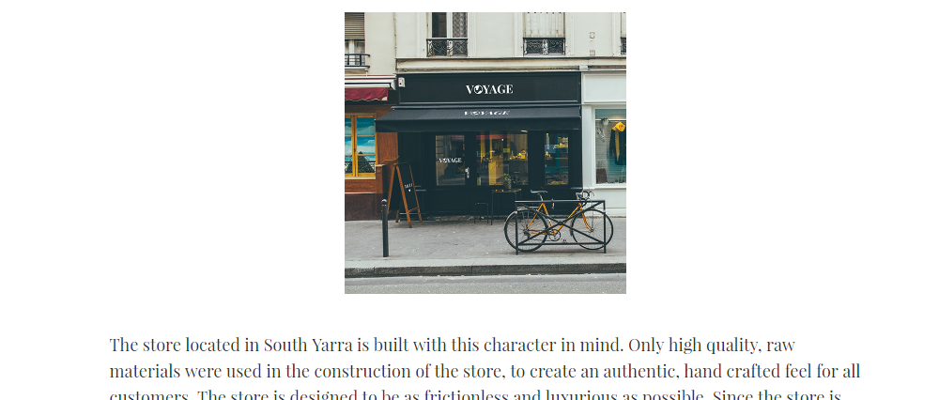

The final task too complete, was to make the products page. I had left this page until last, since I didn’t have a clear idea of what I wanted. After experimenting in Illustrator, I found a relatively simplistic layout which presented the products and prices clearly and succinctly. I exported this PDF so that it can be linked to from the products page. I also decided to base the product page styles off the printable product list.

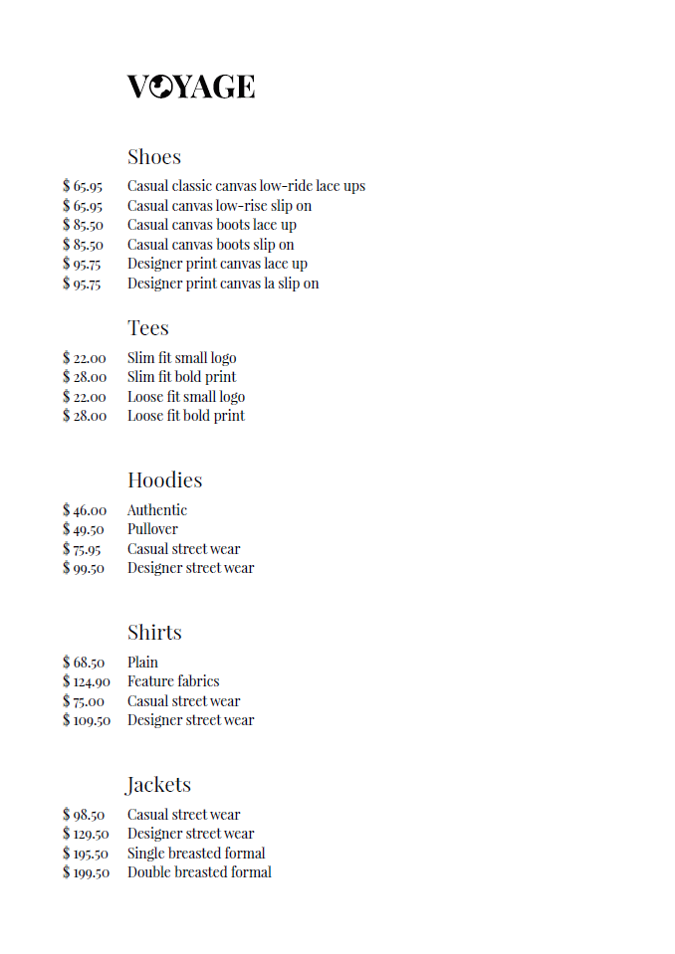

The style was quite easy to recreate in the products page, I just needed to give each price a fixed width in order to achieve the column effect. Below you can see that the result is almost identical to the printable products list.



I decided that the products page was extremely bland, since it didn’t show much other than a really basic products list. I decided to go out looking for appropriate assets for the product page, since I didn’t have that many. I managed to collect a wide variety of images from sources such as Unsplash, and other mock-up websites.

I spent most of the lesson modifying the mock-ups so that the logo, Voyage appeared on the t-shirts and other merchandise. This is usually quite a simplistic process, whereby you open the Photoshop file, edit a preconfigured layer inside the document, which automatically transforms your image onto the product in the image.

After collecting around nine different images I used the image grid, which I created for the home page to place the images at the bottom of the products page. This was extremely easy to do, as all I had to do was modify the HTML from the home page to use the new product images.

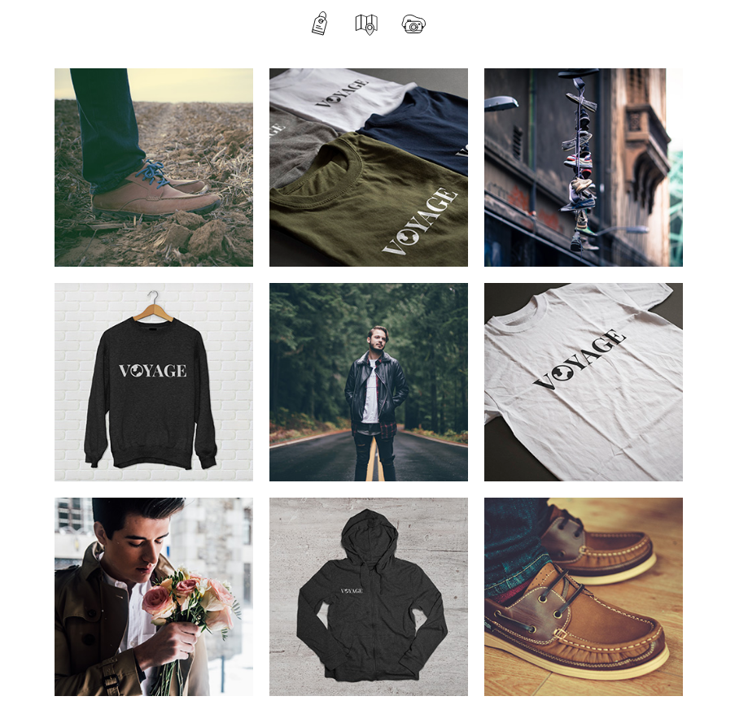

Finally, I needed to include a link to the printable version of the products list. In order to do this, I created a simple bordered button style and floated it onto the right hand side of the page. I placed the button in an easy to find position, and ensured that it linked to the printable PDF.

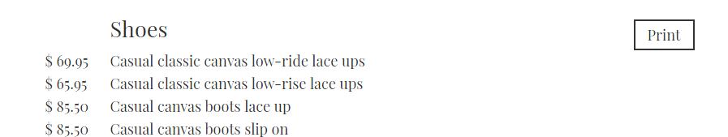

The website is basically finished, however since I have some time to polish some areas, I decided that the biography page was felt fairly plain, as unlike the other pages it felt like a large wall of text. In order to help break the text up a bit I decide to include some images. After browsing Unsplash, I found plenty of images of Melbourne and France which I could include in the biography.

I downloaded these images, and optimised them. I realised I never showed my asset refinement process, so I’ll quickly show how it is done. First the image is loaded into Photoshop, and using the selection tool with a 1:1 ratio I select an area of the image which I wish to crop it too.

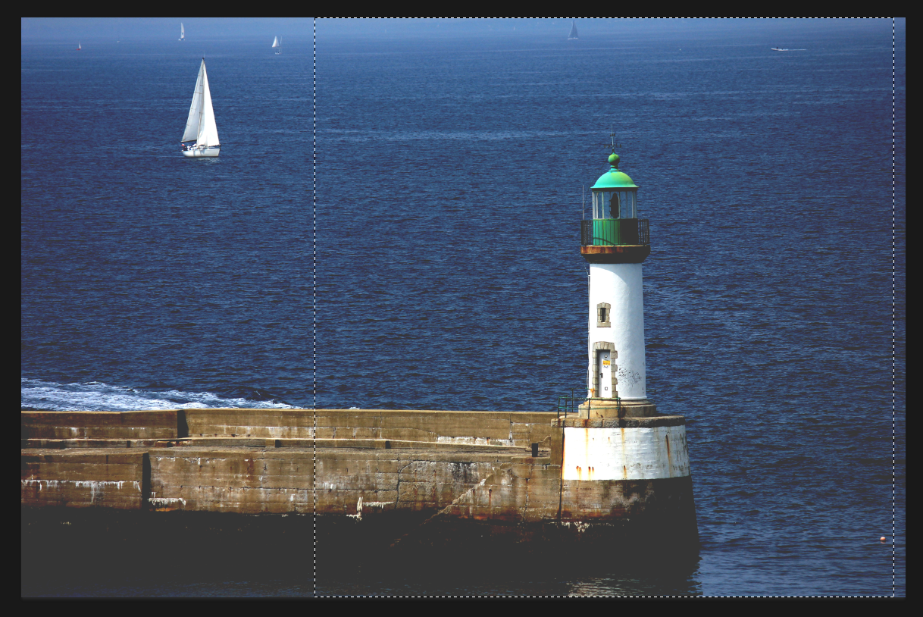

I use the crop tool to trim the image down into a square. This is the square that will appear in the image grid. Since Unsplash images are extremely high resolution, these cropped images can still be around 2000 pixels in width and height.

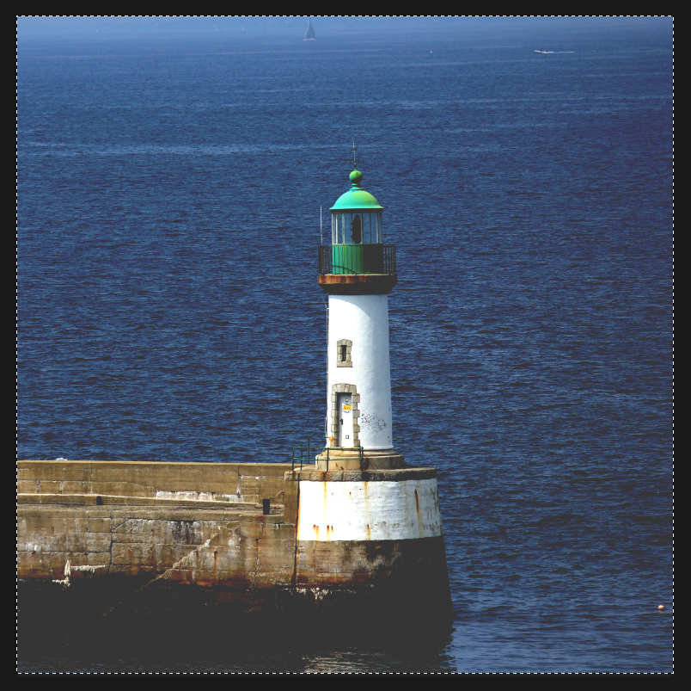

In order to fix this, I created a preset resize setting, which resizes the image to a size of 300 pixels in size. This means I can select the present ‘thumbnail_300’ from the dropdown list, and resize the image to my predefined size.

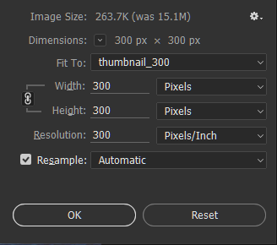

I then save the image as a JPEG. This process generally reduces my thumbnails down to an acceptable size for the web medium.

After collecting these images, it was extremely easy to embed them into the page, as I already have the framework and styles in place to easily format them into a grid.

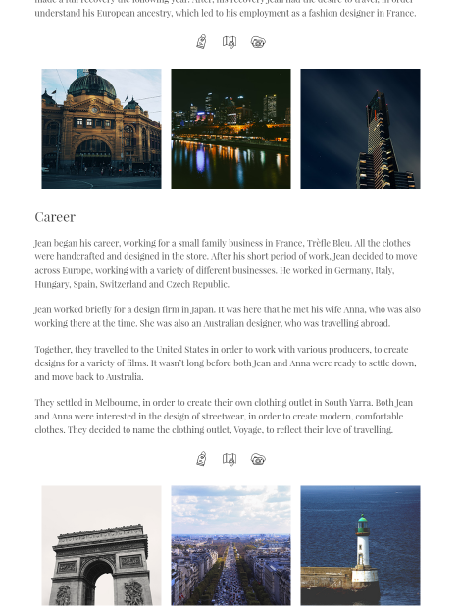

The images definitely help break up the content on the page, and make it more pleasant to read.

Finally, I did my validation check, which showed only four warnings initially. The first warning was easy to fix, as I just had to add metadata to my HTML document to list that it is written in English. The other warnings just recommend that you use a variety of headers within the section tags which I was using. It is okay to leave this, as the warnings are just recommendations, but using section tags without the use of a variety of subheadings will not cause the website to fail on any client. It just goes against the semantic definition of that tag, therefore is okay to leave alone.

